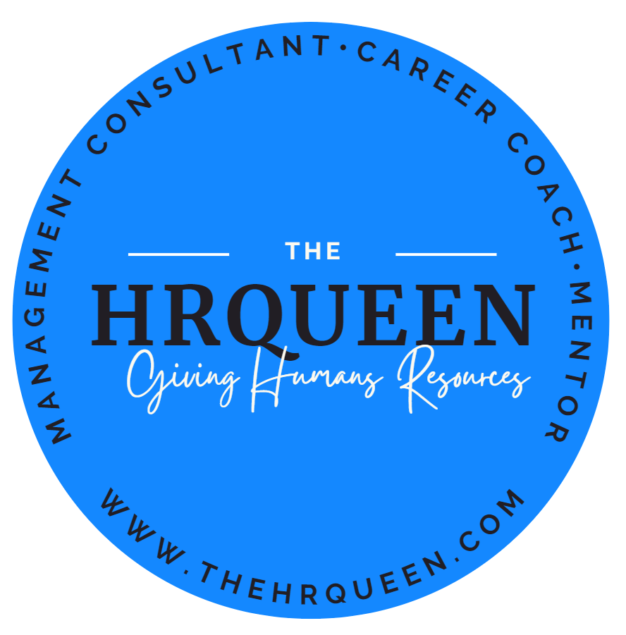

Your Personalized Career Plan Template

Introduction:
Hello Mentees!
Welcome to your Personalized Career Plan Template! This tool has been specifically designed to help you navigate the journey of your professional growth and development. Your career is an important aspect of your life, and having a well-defined plan can make a significant difference in achieving your goals and reaching your full potential.
This Career Plan Template will guide you through the process of setting meaningful objectives, identifying your strengths and weaknesses, and outlining actionable steps to achieve your professional aspirations. By following this template, you'll gain clarity on your career path and be better equipped to tackle challenges and seize opportunities that come your way.
As you complete this template, remember that your career journey is unique, and this plan should be tailored to suit your individual needs and ambitions. Don't hesitate to reach out for guidance or assistance when necessary. I'm here to support you and help you find resources and courses to refine your plan further.
Together, we'll work towards your professional success and make your dreams a reality. Let's embark on this exciting journey and create a career plan that will propel you towards your goals!
Happy planning!

SAMPLE:
Becoming an HR Manager with Exceptional Leadership Skills

Instructions:

- Use this sample table as a guide to creating your own career plan based on your unique goals and objectives.

- Update the table regularly to track your progress and adjust your goals as needed.

Note: If you're looking for a more customized career plan and guidance in finding the right resources and courses to help you achieve your goals, consider joining my 1-on-1 mentoring program. As part of this program, I will work closely with you to create a personalized plan tailored to your needs and aspirations, and help you find the best resources and courses to support your growth. To learn more about the 1-on-1 mentoring program, please visit Employees | Corporate Mentorship by the #HRQUEEN (thehrqueen.com) or contact us at info@thehrqueen.com.

Stage | Goal | Timeframe | Required Skills | Action Steps | Resources Needed | Progress
Short-Term (1) | Obtain an HR certification | 6 months | HR knowledge, Time management | 1. Research suitable HR certifications | HR certification programs, and Study materials | Ongoing
 |  |  |  | 2. Enroll in a certification program | Financial resources, Time
 |  |  |  | 3. Study and complete the certification exam | Study plan, Exam schedule
Short-Term (2) | Develop effective communication skills | 3 months | Communication, Interpersonal skills | 1. Attend a communication workshop | Workshop registration, Time | [Status]
 |  |  |  | 2. Practice active listening | Real-life situations, Feedback from peers
 |  |  |  | 3. Seek feedback from peers and mentors | Constructive criticism, Supportive network
Medium-Term (1) | Gain experience in HR | 2 years | HR knowledge, Conflict resolution | 1. Apply for HR positions or internships | Job search resources, Networking events | [Status]
 |  |  |  | 2. Attend networking events for HR | Business cards, Professional attire
 |  |  |  | 3. Seek mentorship from experienced HR pros | Mentorship program, LinkedIn connections
Medium-Term (2) | Enhance leadership skills | 1 year | Decision-making, Team management | 1. Attend a leadership course or workshop | Course registration, Time, Financial resources | [Status]
 |  |  |  | 2. Volunteer for leadership roles at work | Support from supervisors, Time
 |  |  |  | 3. Seek feedback on leadership performance | Constructive criticism, Supportive network
Long-Term (1) | Become an HR manager | 5 years | HR knowledge, Leadership, Problem-solving | 1. Update resume and apply for HR manager roles | Job search resources, Updated resume | [Status]
 |  |  |  | 2. Prepare for interviews | Interview preparation resources, Mock interviews
 |  |  |  | 3. Network with HR managers and executives | Networking events, LinkedIn connections
Long-Term (2) | Become an exceptional leader | Ongoing | Empathy, Adaptability, Vision | 1. Continue personal development in  leadership | Books, Workshops, Mentorship | [Status]
 |  |  |  | 2. Seek and provide mentorship | Mentorship program, Supportive network
 |  |  |  | 3. Stay informed about industry trends | Industry news, Networking events, Webinars

Your Career Plan Template:

Instructions:

- Fill in the template with your short-term (within 1 year), medium-term (1-3 years), and long-term (3+ years) goals.

- For each goal, including the target completion date, required skills, action steps, resources needed, and progress.

- Update the template regularly to track your progress and adjust your goals as needed.

Stage | Goal | Timeframe | Required Skills | Action Steps | Resources Needed | Progress
Short-Term (1) | [Description] | [Date] | [List skills] | 1. [Action Step] | [List resources] | [Status]
 |  |  |  | 2. [Action Step]
 |  |  |  | 3. [Action Step]
Short-Term (2) | [Description] | [Date] | [List skills] | 1. [Action Step] | [List resources] | [Status]
 |  |  |  | 2. [Action Step]
 |  |  |  | 3. [Action Step]
Medium-Term (1) | [Description] | [Date] | [List skills] | 1. [Action Step] | [List resources] | [Status]
 |  |  |  | 2. [Action Step]
 |  |  |  | 3. [Action Step]
Medium-Term (2) | [Description] | [Date] | [List skills] | 1. [Action Step] | [List resources] | [Status]
 |  |  |  | 2. [Action Step]
 |  |  |  | 3. [Action Step]
Long-Term (1) | [Description] | [Date] | [List skills] | 1. [Action Step] | [List resources] | [Status]
 |  |  |  | 2. [Action Step]
 |  |  |  | 3. [Action Step]
Long-Term (2) | [Description] | [Date] | [List skills] | 1. [Action Step] | [List resources] | [Status]
 |  |  |  | 2. [Action Step]
 |  |  |  | 3. [Action Step]

